ES-API

(Equipment Status API)

solution validation test guide

# Table of content

1. Table of content 2

2. Document history 3

3. Document purpose 3

4. Abbreviations 3

5. Tested solution 4

5.1. Date 4

5.2. Solution Provider 4

5.3. Tested solution 4

6. Recommended solution design flow 5

7. Equipment status API solution validation test guide 6

7.1. Setup 6

7.2. Authentication check and resource retrieval 6

7.3. Data retrieval 7

7.4. Data mapping and rendering 8

7.5. Other system functionality checks 9

Legend: 9

8. Solution under test details 11

# Document history

|  |  |  |
| --- | --- | --- |
| Date | Description | Author |
| May 24.2021 | KONE Equipment Status API 1.0.0 | KONE API Support |
| Nov 08, 2021 | updated with new developer experience | KONE API Support |
| Jan 03, 2023 | KONE Equipment Status API 2.0 | KONE API Support |
| July 28, 2023 | Test cases improvements | KONE API Support |

# Document purpose

Ensuring the quality and security of a solution is every developer’s responsibility. This document gives guidance on evaluating the readiness of those solutions that use Equipment Status API. Practical examples of the expected testing support you in the validation. You can also use this guide as a template for documenting test results.

The test environment used in these test scenarios has been designed to resemble an elevator setup in a building. Solution validation is needed before connecting a solution to KONE equipment.

# Abbreviations

|  |  |
| --- | --- |
| **Abbreviation** | **Description** |
| ES-API | Equipment Status Application Programming Interface |

# Tested solution

# Date

|  |  |
| --- | --- |
| Test Date (dd.mm.yyyy): |  |

## Solution Provider

|  |  |
| --- | --- |
| Company name |  |
| Company address |  |
| Contact person name |  |
| Email |  |
| Telephone number |  |
| Tester |  |

## Tested solution

|  |  |
| --- | --- |
| System name: |  |
| System version: |  |
| Software name: |  |
| Software version: |  |
| KONE ES-API: | v2.0 |
| KONE test assistant email |  |

# Recommended solution design flow

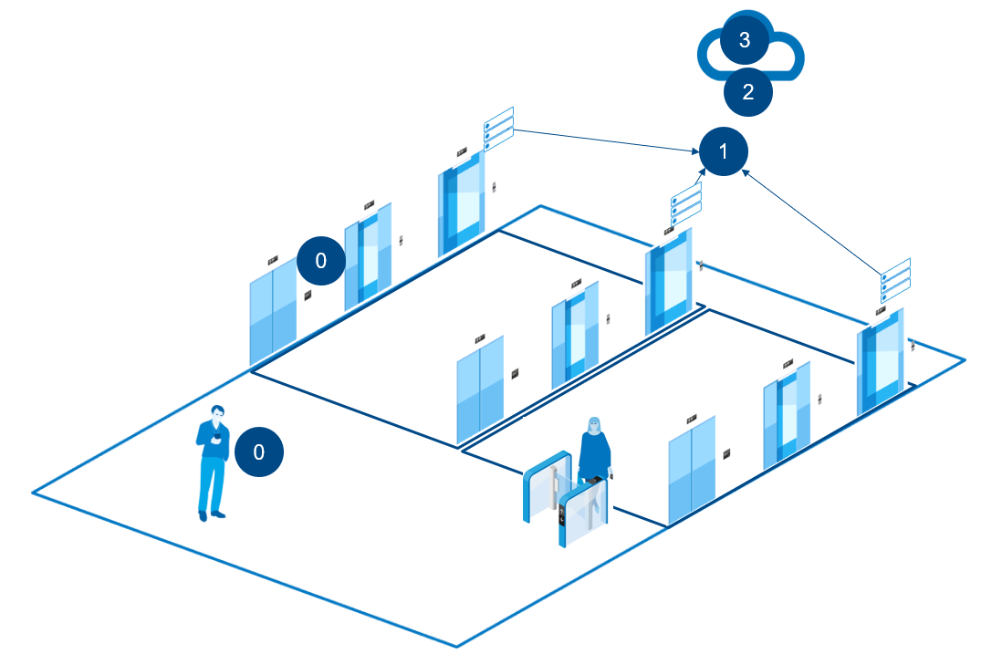

|  |  |
| --- | --- |
| Flow | Description |
| 0 | Power saving |
| 1 | Multiple equipment support |
| 2 | Cybersecurity measures |
| 3 | Logs |

# Equipment status API solution validation test guide

This test focus on retrieving equipment status with Equipment status API.

## Setup

|  |  |
| --- | --- |
| Pre-step | Get access to the equipment for testing.   * Virtual equipment, available in KONE API portal * Demo equipment, by contacting KONE API Support (api-support@kone.com) |
| Expected result | - Test environments available for the correct KONE API organization.  - Equipment number can be retrieved (/resource endpoint) |

## Authentication check and resource retrieval

|  |  |
| --- | --- |
| Test 1 | Solution initialization – permitted token |
| Expected | - access token for scope application/inventory  - Response code 200  - Response code 401 in case if there is issue with API Credentials  - Error "type": "invalid", "header": "authorization"  - Response code 400 in case if there is issue with grant type  - Error "type": "unsupportedType", "bodyPath": "grant_type" |
| Test result |  |

|  |  |
| --- | --- |
| Test 2 | Solution initialization – permitted equipment reference |
| Expected | - equipment inventory  - Response code 200  - Response code 401 in case if there is issue with access token  - Error "message": "Unauthorized" |
| Test result |  |

|  |  |
| --- | --- |
| Test 3 | Solution initialization – scope equipment reference |
| Expected | - access token for Scope - each valid equipment. **(note wildcard not to be used)**  - Response code 200  - Response code 403 in case if there is issue with Equipment number  - Error "type": "not_allowed", "bodyPath": "scope"  - Response code 401 in case if there is issue with API Credentials  - Error "type": "invalid", "header": "authorization"  - Response code 400 in case if there is issue with grant type  - Error "type": "unsupportedType", "bodyPath": "grant_type" |
| Test result |  |

## Data retrieval

|  |  |  |
| --- | --- | --- |
| Functionality declaration 1 | Equipment status data retrieval means. Provide brief description of data retrieval method. | |
| Comment | REST |  |
| WEBHOOK Portal UI |  |
| WEBHOOK Client |  |

|  |  |
| --- | --- |
| Test 4 | Equipment status - equipment availability status retrieval (include message flow if webhook) |
| Expected result | - Equipment basic information  - Response code 200  - Response code 401 in case if there is issue with access token  - Error "message": "Unauthorized"  - Response code 403 in case if there is issue with equipment number  - Error "message": "Token does not contain required scopes..... |
| Test result |  |

|  |  |
| --- | --- |
| Test 5 | Equipment status – latest reported status retrieval (include message flow if webhook) |
| Expected result | - Equipment latest reported status  - Response code 200  - Response code 401 in case if there is issue with access token  - Error "message": "Unauthorized"  - Response code 403 in case if there is issue with equipment number  - Error "message": "Token does not contain required scopes.....  - Response code 404 in case if there is issue with equipment contract validity  - Error "message": "The requested resource is not found" |
| Test result |  |

|  |  |
| --- | --- |
| Test 6 | Equipment status – latest completed movement retrieval (include message flow if webhook) |
| Expected result | - Equipment latest reported status  - Response code 200  - Response code 401 in case if there is issue with access token  - Error "message": "Unauthorized"  - Response code 403 in case if there is issue with equipment number  - Error "message": "Token does not contain required scopes.....  - Response code 404 in case if there is issue with equipment contract validity  - Error "message": "The requested resource is not found" |
| Test result |  |

## Data mapping and rendering

|  |  |  |
| --- | --- | --- |
| Functionality declaration 2 | Equipment status - equipment **availability** information mapping.  describe how each data is used in your solution. meaning what type of information it delivers to your application users | |
| Comment | **Data** | **Mapping** |
| <data1> |  |
| <data2> |  |
| <data3> |  |

|  |  |  |
| --- | --- | --- |
| Functionality declaration 3 | Equipment status - latest reported **status** mapping.  describe how each data is used in your solution. meaning what type of information it delivers to your application users | |
| Comment | **Data** | **Mapping** |
| <data1> |  |
| <data2> |  |
| <data3> |  |

|  |  |  |
| --- | --- | --- |
| Functionality declaration 4 | Equipment status - latest **completed movement** mapping.  describe how each data is used in your solution. meaning what type of information it delivers to your application users | |
| Comment | **Data** | **Mapping** |
| <data1> |  |
| <data2> |  |
| <data3> |  |

|  |  |
| --- | --- |
| Test 7 | Mapping for multiple equipment |
| Expected result | - Verifiable that mapping is consistent for all equipment |
| Test result |  |

|  |  |  |
| --- | --- | --- |
| Functionality declaration 5 | Equipment status - equipment **availability** information rendering.  describe how each data is presented in your solution. meaning how they are displayed to your application users. screencapture of how a data is displayed can be pasted here | |
| Comment | **Data** | **Rendering** |
| <data1> |  |
| <data2> |  |
| <data3> |  |

|  |  |  |
| --- | --- | --- |
| Functionality declaration 6 | Equipment status - latest reported **status** mapping.  describe how each data is presented in your solution. meaning how they are displayed to your application users. screencapture of how a data is displayed can be pasted here | |
| Comment | **Data** | **Rendering** |
| <data1> |  |
| <data2> |  |
| <data3> |  |

|  |  |  |
| --- | --- | --- |
| Functionality declaration 7 | Equipment status - latest reported **status** mapping.  describe how each data is presented in your solution. meaning how they are displayed to your application users. screencapture of how a data is displayed can be pasted here | |
| Comment | **Data** | **Rendering** |
| <data1> |  |
| <data2> |  |
| <data3> |  |

|  |  |
| --- | --- |
| Test 8 | Rendering for multiple equipment |
| Expected result | - Verifiable that rendering is consistent for all equipment |
| Test result |  |

## Other system functionality checks

|  |  |
| --- | --- |
| Functionality declaration 8 | Specify how *logs* for data retrieval are handled. |
| Comment |  |

|  |  |
| --- | --- |
| Functionality declaration 9 | specify used *power saving* technique / battery management if mobile application. |
| Comment |  |

|  |  |
| --- | --- |
| Functionality declaration 10 | Self-assessment *cyber security* form filled |
| Comment |  |

|  |  |
| --- | --- |
| Test 9 | Custom case |
| Expected result |  |
| Test result |  |

## Legend:

|  |  |
| --- | --- |
|  | Ok / Passed |
|  | pending implementation |
|  | not tested / not passed |

# Solution under test details

Solution description:-

use case:-

Sequence diagram:-